**What is Herbalife: Business Plan, Is it Safe, Reviews?**

We have provided the full information about the company. Don’t forget to read the reviews. We have fully revealed about the company.

## **What is Herbalife?**

## 

**Herbalife Nutrition Ltd.** is a global [multi-level marketing](https://en.wikipedia.org/wiki/Multi-level_marketing)(MLM) corporation that develops and sells [dietary supplements](https://en.wikipedia.org/wiki/Dietary_supplements). The company was founded by [Mark R. Hughes](https://en.wikipedia.org/wiki/Mark_R._Hughes) in 1980, and it employs an estimated 9,900 people worldwide. The business is incorporated in the [Cayman Islands](https://en.wikipedia.org/wiki/Cayman_Islands),

with its corporate headquarters located in [Los Angeles](https://en.wikipedia.org/wiki/Los_Angeles), [California](https://en.wikipedia.org/wiki/California). The company operates in 95 countries through a network of approximately 4.5 million independent distributors and members. [John O. Agwunobi](https://en.wikipedia.org/wiki/John_O._Agwunobi) has been the company's chief executive officer and executive chairman since March 2020.

The company has been criticized for allegedly operating a "sophisticated [pyramid scheme](https://en.wikipedia.org/wiki/Pyramid_scheme)".Herbalife agreed to "fundamentally restructure" its business, in the US but not worldwide, and pay a $200 million fine as part of a 2016 settlement with the [U.S. Federal Trade Commission](https://en.wikipedia.org/wiki/U.S._Federal_Trade_Commission) (FTC) following these accusations.

### **How does Herbalife Help others to Make Money?**

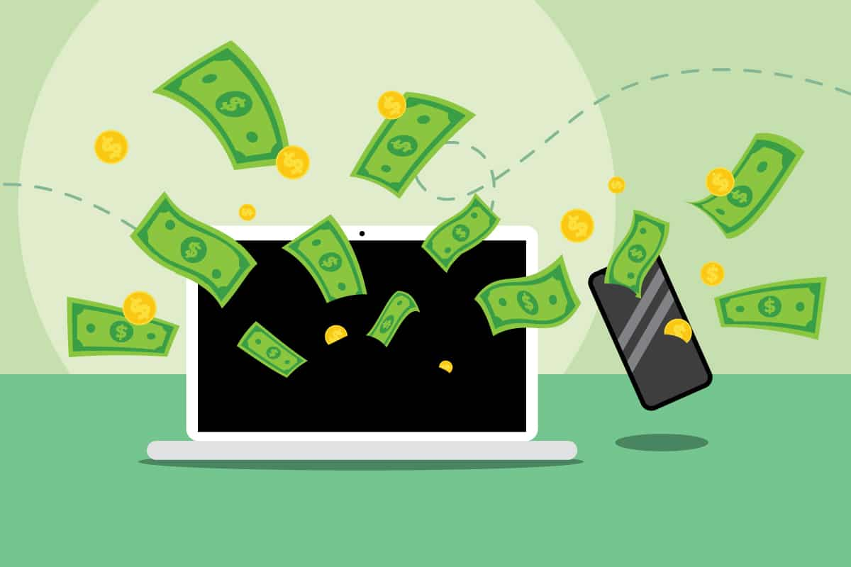

I’ll help you explore how you can leverage MLM as a business system and how it can help you make money with Herbalife. The first step to making money selling Herbalife is to think like an entrepreneur. Network marketing is a business system where you sell products and services to customers, regardless of whether they’re from your social circle or not. In this way, it’s similar to online businesses that leverage platforms such as Amazon, eBay, Shopify, etc.

[**Stock price**](https://www.google.com/search?sa=X&rlz=1C1CHBF_enIN972IN974&hl=en&biw=1536&bih=688&sxsrf=ALiCzsbyCy2D_1SXOBGtIbzEllahr1jMuA:1664372407393&q=herbalife+nutrition+stock+price&stick=H4sIAAAAAAAAAONgecRozi3w8sc9YSm9SWtOXmPU4OIKzsgvd80rySypFJLiYoOyBKT4uHj00_UNM5LKyrNyjUx4FrHKZ6QWJSXmZKalKuSVlhRllmTm5ykUl-QnZysUFGUmpwIA6409Y14AAAA&ved=2ahUKEwjNgvewzrf6AhXPwAIHHdWJCagQ6BN6BAhhEAI&cshid=1664372416801844)**:**[HOO](https://www.google.com/search?sa=X&rlz=1C1CHBF_enIN972IN974&hl=en&biw=1536&bih=688&sxsrf=ALiCzsbyCy2D_1SXOBGtIbzEllahr1jMuA:1664372407393&q=FRA:+HOO&stick=H4sIAAAAAAAAAONgecRozi3w8sc9YSm9SWtOXmPU4OIKzsgvd80rySypFJLiYoOyBKT4uHj00_UNM5LKyrNyjUx4FrFyuAU5Wil4-PsDAMueriNHAAAA&ved=2ahUKEwjNgvewzrf6AhXPwAIHHdWJCagQsRV6BAhhEAM&cshid=1664372416801844) (FRA) €22.68 -0,05 (-0,20 %)

[**Founder**](https://www.google.com/search?sa=X&rlz=1C1CHBF_enIN972IN974&hl=en&biw=1536&bih=688&sxsrf=ALiCzsbyCy2D_1SXOBGtIbzEllahr1jMuA:1664372407393&q=herbalife+nutrition+founder&stick=H4sIAAAAAAAAAOPgE-LUz9U3MLZIiy_RUs9OttJPKi3OzEstLoYz4vMLUosSSzLz86zS8kvzUlKLFrFKZ6QWJSXmZKalKuSVlhRlgmQVoLIAqBO4HFQAAAA&ved=2ahUKEwjNgvewzrf6AhXPwAIHHdWJCagQ6BMoAHoECGgQAg&cshid=1664372416801844)**:**[Mark R. Hughes](https://www.google.com/search?sa=X&rlz=1C1CHBF_enIN972IN974&hl=en&biw=1536&bih=688&sxsrf=ALiCzsbyCy2D_1SXOBGtIbzEllahr1jMuA:1664372407393&q=Mark+R.+Hughes&stick=H4sIAAAAAAAAAOPgE-LUz9U3MLZIiy9RAjPNy8uTDbTUs5Ot9JNKizPzUouL4Yz4_ILUosSSzPw8q7T80ryU1KJFrHy-iUXZCkF6Ch6l6RmpxTtYGXexM3EwAAClhtxLWgAAAA&ved=2ahUKEwjNgvewzrf6AhXPwAIHHdWJCagQmxMoAXoECGgQAw&cshid=1664372416801844)

[**CEO**](https://www.google.com/search?sa=X&rlz=1C1CHBF_enIN972IN974&hl=en&biw=1536&bih=688&sxsrf=ALiCzsbyCy2D_1SXOBGtIbzEllahr1jMuA:1664372407393&q=herbalife+nutrition+ceo&stick=H4sIAAAAAAAAAOPgE-LUz9U3MLZIiy_RUsxOttLPL0pPzMusSizJzM9D4Vglp-YvYhXPSC1KSszJTEtVyCstKcoEySgAZQD9DY33SgAAAA&ved=2ahUKEwjNgvewzrf6AhXPwAIHHdWJCagQ6BMoAHoECGcQAg&cshid=1664372416801844)**:**[John O. Agwunobi](https://www.google.com/search?sa=X&rlz=1C1CHBF_enIN972IN974&hl=en&biw=1536&bih=688&sxsrf=ALiCzsbyCy2D_1SXOBGtIbzEllahr1jMuA:1664372407393&q=John+O.+Agwunobi&stick=H4sIAAAAAAAAAOPgE-LUz9U3MLZIiy9R4gIxjcwq440rtRSzk63084vSE_MyqxJLMvPzUDhWyan5i1gFvPIz8hT89RQc08tL8_KTMnewMu5iZ-JgAAAI6tiwVwAAAA&ved=2ahUKEwjNgvewzrf6AhXPwAIHHdWJCagQmxMoAXoECGcQAw&cshid=1664372416801844) (Mar 30, 2020–)

[**Headquarters**](https://www.google.com/search?sa=X&rlz=1C1CHBF_enIN972IN974&hl=en&biw=1536&bih=688&sxsrf=ALiCzsbyCy2D_1SXOBGtIbzEllahr1jMuA:1664372407393&q=herbalife+nutrition+headquarters&stick=H4sIAAAAAAAAAOPgE-LUz9U3MLZIiy_R0spOttLPL0pPzMusSizJzM9D4VhlpCamFJYmFpWkFhUvYlXISC1KSszJTEtVyCstKcoEKVFAVgIAUlwZqlwAAAA&ved=2ahUKEwjNgvewzrf6AhXPwAIHHdWJCagQ6BMoAHoECGYQAg&cshid=1664372416801844)**:**[Los Angeles, California, United States](https://www.google.com/search?sa=X&rlz=1C1CHBF_enIN972IN974&hl=en&biw=1536&bih=688&sxsrf=ALiCzsbyCy2D_1SXOBGtIbzEllahr1jMuA:1664372407393&q=Los+Angeles&stick=H4sIAAAAAAAAAOPgE-LUz9U3MLZIiy9R4gIzDQqTjEu0tLKTrfTzi9IT8zKrEksy8_NQOFYZqYkphaWJRSWpRcWLWLl98osVHPPSU3NSi3ewMu5iZ-JgAADlNkhOWwAAAA&ved=2ahUKEwjNgvewzrf6AhXPwAIHHdWJCagQmxMoAXoECGYQAw&cshid=1664372416801844)

[**Revenue**](https://www.google.com/search?sa=X&rlz=1C1CHBF_enIN972IN974&hl=en&biw=1536&bih=688&sxsrf=ALiCzsbyCy2D_1SXOBGtIbzEllahr1jMuA:1664372407393&q=herbalife+nutrition+revenue&stick=H4sIAAAAAAAAAOPgE-LUz9U3MLZIiy_RUskot9JPzs_JSU0uyczP088vSk_My6xKBHGKrYpSy1LzSlMXsUpnpBYlJeZkpqUq5JWWFGWCpBWgsgDTVjG4UQAAAA&ved=2ahUKEwjNgvewzrf6AhXPwAIHHdWJCagQ6BMoAHoECGUQAg&cshid=1664372416801844)**:**5.54 billion USD (2020)

[**Founded**](https://www.google.com/search?sa=X&rlz=1C1CHBF_enIN972IN974&hl=en&biw=1536&bih=688&sxsrf=ALiCzsbyCy2D_1SXOBGtIbzEllahr1jMuA:1664372407393&q=herbalife+nutrition+founded&stick=H4sIAAAAAAAAAOPgE-LUz9U3MLZIiy_RUs1OttLPL0pPzMusSizJzM9D4Vil5ZfmpaSmLGKVzkgtSkrMyUxLVcgrLSnKBMkqQGUBzHclS1IAAAA&ved=2ahUKEwjNgvewzrf6AhXPwAIHHdWJCagQ6BMoAHoECGMQAg&cshid=1664372416801844)**:**February 1980, [Los Angeles, California, United States](https://www.google.com/search?sa=X&rlz=1C1CHBF_enIN972IN974&hl=en&biw=1536&bih=688&sxsrf=ALiCzsbyCy2D_1SXOBGtIbzEllahr1jMuA:1664372407393&q=Los+Angeles&stick=H4sIAAAAAAAAAOPgE-LUz9U3MLZIiy9R4gIzDQqTjEu0VLOTrfTzi9IT8zKrEksy8_NQOFZp-aV5Kakpi1i5ffKLFRzz0lNzUot3sDLuYmfiYAAA0aEWMFYAAAA&ved=2ahUKEwjNgvewzrf6AhXPwAIHHdWJCagQmxMoAXoECGMQAw&cshid=1664372416801844)

[**Net income**](https://www.google.com/search?sa=X&rlz=1C1CHBF_enIN972IN974&hl=en&biw=1536&bih=688&sxsrf=ALiCzsbyCy2D_1SXOBGtIbzEllahr1jMuA:1664372407393&q=herbalife+nutrition+net+income&stick=H4sIAAAAAAAAAOPgE-LUz9U3MLZIiy_RUs8ot9JPzs_JSU0uyczP088vSk_My6xKBHGKrfJSSxQy85Lzc1MXscplpBYlJeZkpqUq5JWWFGWCVCggFAAAleHR4VcAAAA&ved=2ahUKEwjNgvewzrf6AhXPwAIHHdWJCagQ6BMoAHoECGQQAg&cshid=1664372416801844)**:**372.6 million USD (2020)

[**Subsidiaries**](https://www.google.com/search?sa=X&rlz=1C1CHBF_enIN972IN974&hl=en&biw=1536&bih=688&sxsrf=ALiCzsbyCy2D_1SXOBGtIbzEllahr1jMuA:1664372407393&q=herbalife+nutrition+subsidiaries&stick=H4sIAAAAAAAAAOPgE-LUz9U3MLZIiy_R0swot9JPzs_JSU0uyczP088vSk_My6xKBHGKrYpLk4ozUzITizJTixexKmSkFiUl5mSmpSrklZYUZYLUKCArAQBLwO1-WwAAAA&ved=2ahUKEwjNgvewzrf6AhXPwAIHHdWJCagQ6BMoAHoECGkQAg&cshid=1664372416801844)**:**[Herbalife International India Private Ltd](https://www.google.com/search?sa=X&rlz=1C1CHBF_enIN972IN974&hl=en&biw=1536&bih=688&sxsrf=ALiCzsbyCy2D_1SXOBGtIbzEllahr1jMuA:1664372407393&q=Herbalife+International+India+Private+Ltd&stick=H4sIAAAAAAAAAOPgE-LUz9U3MLZIiy9R4gIxLfOM4wtztDQzyq30k_NzclKTSzLz8_Tzi9IT8zKrEkGcYqvi0qTizJTMxKLM1OJFrJoeqUVJiTmZaakKnnklqUV5YFWJOUAeUI1CQFFmWWJJqoJPScoOVsZd7EwcDADuggmgeAAAAA&ved=2ahUKEwjNgvewzrf6AhXPwAIHHdWJCagQmxMoAXoECGkQAw&cshid=1664372416801844).

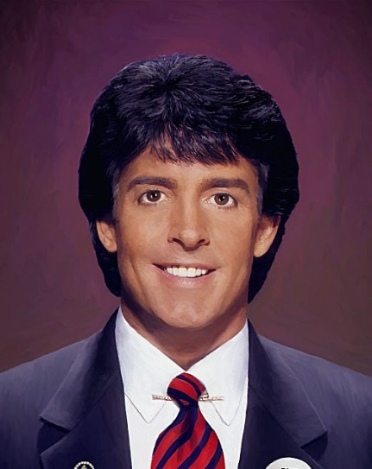

**Your Warm Market May or May Not Work!**

One mistake new Herbalife distributor make is trying to focus on selling their products to their family and friends only. Although it’s ideal if your close network is interested in the products you’re selling, this isn’t always the case. You can still profit with Herbalife even if they don’t want to purchase anything from you.

**For example**, let’s say you have a friend named Jane who wants to lose weight. Although she’s not interested in buying supplements from me, you can still help her by providing a fitness routine and healthy recipes. In exchange for your free services, Jane would promote your business to other people who want to make money by building a Herbalife business of their own. In this case, you’d make money from your friend Jane by helping her achieve her fitness goals.

In another scenario, let’s say you have a relative named John who’s into healthy products. You recommend that he purchase the Herbalife starter pack so you can start sharing the products with him. The starter pack includes a set of body wash, shampoo, and conditioner. This might be great for John because he often forgets to buy his usual products at the supermarket.

In this case, you can make a retail profit by helping John purchase something he normally buys anyway. As you can see, there are many ways to look at making money selling Herbalife to friends and family. However, what do you do after you join Herbalife as an independent distributor and you can’t get your warm market to listen?

You go to social media, right? Not so fast!

## **Biggest Mistake Herbalife Distributors Make on social media!**

Too many Herbalife distributors make a mistake on social media. They hurt their ability to sell herbal supplements or wellness products by mentioning Herbalife specifically on Facebook, Tik Tok, Instagram, YouTube, or Twitter. Mentioning the Herbalife compensation plan on social media kills your chances of selling the Herbalife MLM opportunity.

### **You’re Losing Herbalife Compensation Plan $$$ By Posting on social media.**

As soon as your active social media users go elsewhere to investigate Herbalife, you’ve lost all hope to sell Herbalife’s products to them. You’ve lost your chance to bring them in as one of your next Herbalife reps.

Why? Because they’ll likely end up on another Herbalife rep’s website who’s learned what we teach you here. They’ll either buy from another Herbalife distributor who educates them about a specific Herbalife product or Business model after bringing them in as a “captured” lead OR, your lost prospect ends up on the corporate Herbalife website and buys there. Wonderful…you just gave Herbalife another free sale. You’re not recruiting distributors…you’re giving Herbalife corporate free distributors who join Herbalife without crediting any specific rep.

Oops! Ouch!

How can you expect to earn money if you don’t take the time to learn the marketing skills that translate into generating retail sales and downline sales? If you’re tired of wasting your time attempting to sell Herbalife products on social media, it’s no wonder why.

## **How Much Money Can You Make with Herbalife?**

Several ways exist to pocket money with Herbalife. If you join the business, you’ll make money when your customers buy Herbalife products and if they, in turn, refer new Herbalife distributors. The compensation plan is designed to give everyone an equal chance at earning a substantial income by selling good nutrition worldwide through its multi-level international company system.

Why Network Marketing?  – It’s one of the best ways to make money because it has unlimited earning potential with no limits on how much money you can earn. You also have a low start-up cost compared to other businesses, which makes it accessible for anyone looking to work from home either part or full time.

Approximately half of all Herbalife reps earn **$200 to $3000+** every month in commissions.

You should focus on building a strong foundation through product sales and downline sponsorship that will help you earn residual income long-term, or even make it your full-time gig.

## **3 Ways to Make Money Selling Herbalife.**



There are three main ways to earn with Herbalife. They include:

1. **Retail Profit** – You can earn money when you sell Herbalife products to the public. Using social media, people can learn about your business and make a purchase with just one click of their mouse or phone screen.
2. **Downline Commissions** – When new reps join under you as part of your downline team, you’ll earn money on their sales. Even just one sale of $50+ qualifies them for commissions
3. **Sponsoring** – When new reps join under your sponsorship and make at least one retail purchase with Herbalife products in a 30-day period, you can receive up to $2000 from Herbalife.

## **Other Ways Herbalife Distributors Can Make Money**

Once you learn how to become a real Herbalife entrepreneur and sell legitimate health solutions, you can add more income channels to your business owner’s path. You can:

* Start a blog and sell another health-related affiliate offers
* Sell health coaching services and show clients how to purchase Herbalife products
* Earn from ads on your blog’s traffic

Think like an entrepreneur inside your Herbalife journey and watch how many new doors open to you!

## **FAQs (Frequently Asked Questions)**

### 

### **How do you get paid from Herbalife?**

You sell Herbalife products (shakes, supplements, etc) to customers and then get a commission check every month. You also can earn income by building your downline team of distributors who do the same thing you’re doing – selling products. It works like an affiliate program where people order through your link and you get a commission on the sale.

### **How much do you earn as a Herbalife distributor?**

It depends on how hard you work at it. Some people make very little, some make $500 to $2000 every month, and others make a full-time income. As I mentioned above, this is a business. Develop authentic entrepreneurial skills and the sky’s the limit inside a business model that’s existed since 1980.

### **What’s the difference between Herbalife and Arbonne?**

Although similar, they’re two completely separate MLM businesses.

## **How To Make Money Selling Herbalife: Quick Summary**

Network marketing is a great business system you can use to make money by selling Herbalife products. To get started, focus on making product sales at the recommended retail price and downline commissions by sponsoring new distributors who will do the same thing under your leadership.

The opportunity for residual income exists with this type of online business.

As I’ve mentioned throughout the post, the key to your success is to eliminate any tendency to think like an employee. That’s hard in a world where we’re all raised to think like worker bees. Want to learn how to break that conditioning and brainwashing, and instead learn how authentic business owner entrepreneurs create big-time businesses?